***SUPER SUMMER WHITENING SPECIAL!***



Our at home whitening system removes stains and discoloration from your teeth safely and easily. In just a few days you will notice a whiter, brighter, healthier looking smile!

**We are offering a free lower tray with the purchase of an upper tray!**

**That is a $235.00 savings!!!**

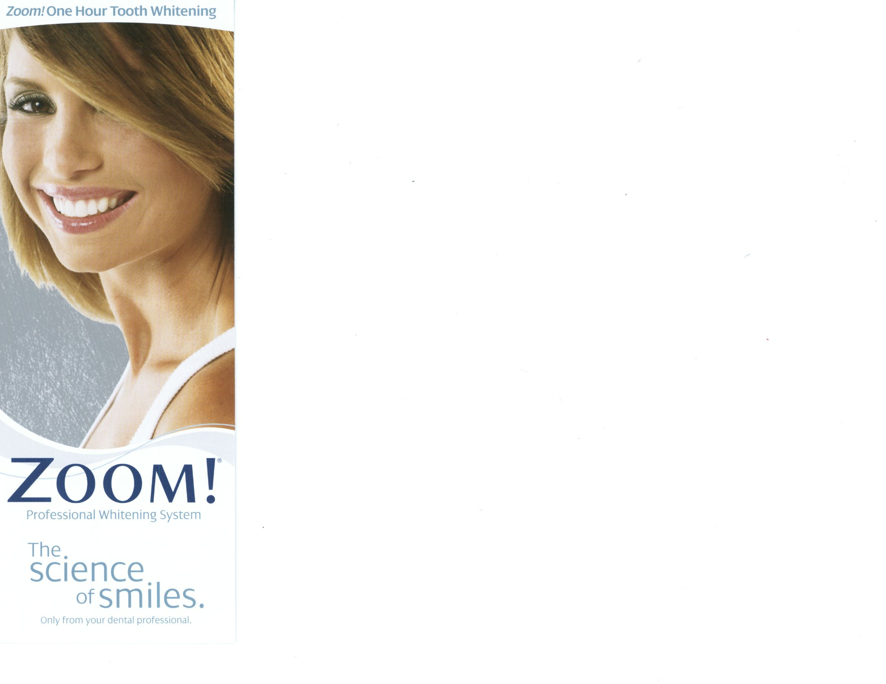

DRS. O’HARA & MASSON

242 MUSTANG TRAIL SUITE 9

VIRGINIA BEACH, VA 23452

(757) 340-1153

www.drsoharaandmasson.com

Our ***ZOOM!*** In-office whiteningsystem is safe, effective, and fast. In less than an hour, your teeth will become dramatically whiter! The convenience of ***ZOOM!*** makes it the perfect choice for the busy individual.

**We are offering $200.00 off our *ZOOM!* In-office whitening system!**